

Department of computer science and technology (2018-2019)

Project title

**Sun-ray tracking solar panel using Arduino**

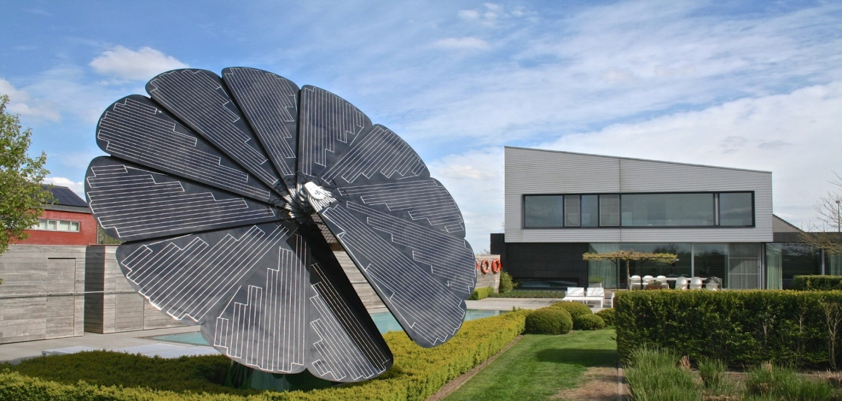

**Our team interest**

**More real time applications…**

* **Used in solar heater, street light system, indoor lighting, power pump, gardening, electricity to rural areas etc….**
* **It can be incorporated in hybrid cars**
* **Mainly this technology can be implemented in satellite**
* **Can be used for large and medium scale power generation**
* **It may be used as domestic backup power system**

**Advantages…**

* **This technology is one time investment**
* **Can give you more profit**

**Submitted by**

**Mariajohn Antony Michael Arulanand- cs280**

**Project outcome**

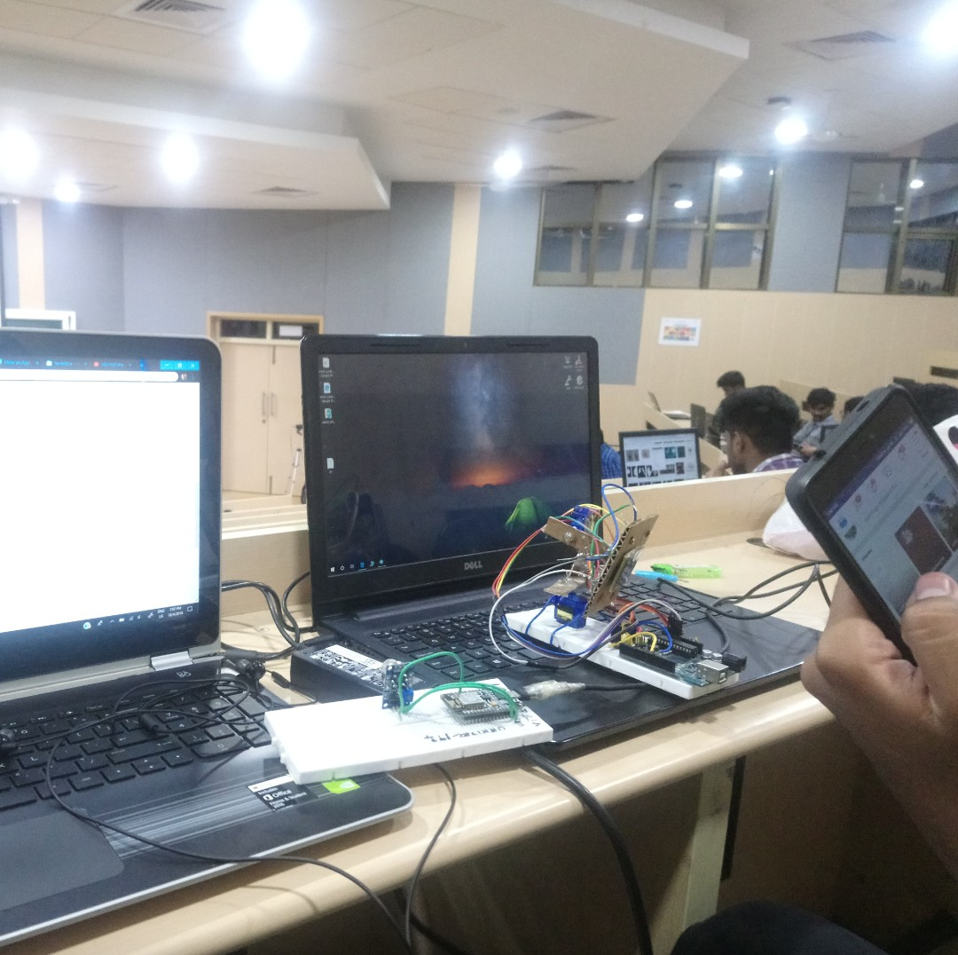

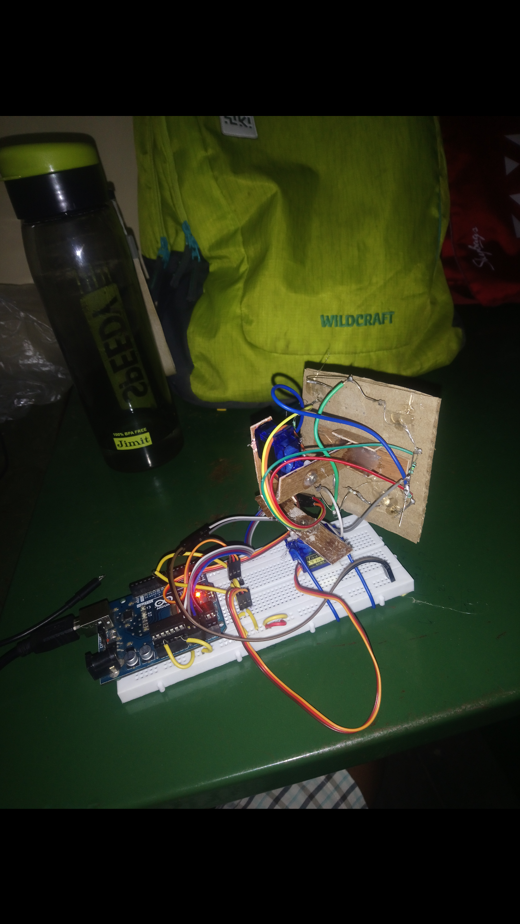

Youtube link:

https://youtu.be/TEUD3D9C9ho